
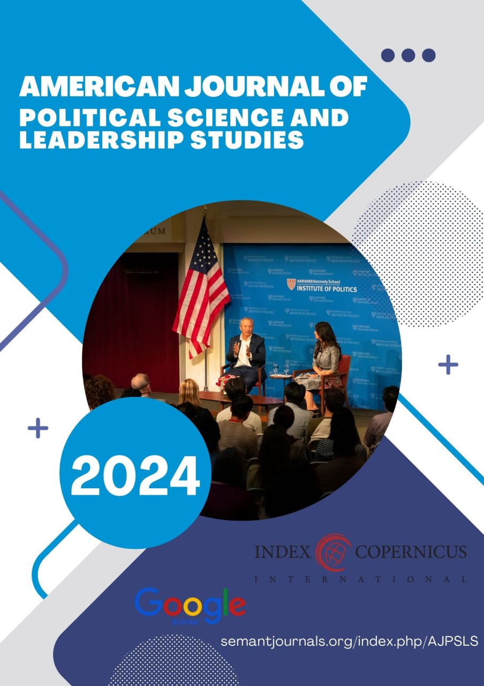
E-ISSN: xxxx - xxxx

American Journal of Religious, Culture, and Archaeological Studies
https://semantjournals.org/index.php/AJRCAS

| Research Article

The History of Abu Ubayda Ibn Al-Jarrah

Boqiyev Ismail
student of Asiant Technology University

Abstract: Abu Ubaydah ibn Jarrah (583 – 639) was a companion, one of the first Meccan Muslims to convert to Islam. His name was Amir, he was from the Banu Fikhr clan of the Quraysh tribe. Abu Ubayda ibn al-Jarrah migrated to Abyssinia and then to Medina. He participated in all gazats with Muhammad (pbuh).



This is an open-access article under the CC-BY 4.0 license

INTRODUCTION

In the history of Islam, he is known as a courageous and courageous mujahideen, a great commander, and a righteous person. His father joined the Meccan polytheists in the Battle of Badr and fought against the Muslim army.
During the Caliphate of Abu Bakr Siddiq, he was sent to conquer Sham (Syria). Abu Ubayda ibn al-Jarrah was just, compassionate and gentle. This situation led to the defeat of the enemy and the capture of Syria without a fight. 639 A severe, bad disease (touni amvos) spread in Syria. The disease first appeared in the village of Amwas in Palestine, and twenty thousand Muslims died from this disease within a month.
Abu Ubayda ibn al-Jarrah also fell victim to this disease. Abu Ubaydah ibn al-Jarrah died in Jordan (Jordan), his grave is in the village of Amyo, on the west side of Shariat river. Umar (ra) considered Abu Ubaid ibn al-Jarrah as a suitable candidate for the caliphate after him. Every community has its own trusted person. Abu Ubaidah is the trusted person of this Ummah. When Muhammad Rasulullah described him, he was a fair-faced man, hot-tempered, thin-skinned, and sparsely bearded.
The eye of the person who saw it was happy, the pleasure of meeting again appeared in his heart, and a warm impression of him arose. In addition, he was extremely polite, quiet, extremely shy. But if the situation worsened and the situation demanded tension, he would become like a lion in anger and become unrecognizable. He is like a sharp sword with his bold and bold behavior.
Abdullah ibn Umar described him as follows: - There are three people in the tribe of Quraysh who are the most open-faced, beautiful moral and imaginative people. If they want to talk to you, they will not tell you a lie. If you tell them, they won't call you a liar. He opined that these are Abu Bakr Siddique, Uthman ibn Affan and Abu Ubaydah ibn al-Jarrah.
Abu Ubaidah was one of the first Muslims to convert to Islam. A day after Abu Bakr Siddiq, he entered the religion at the invitation of a man and went to the presence of the Prophet, peace be upon him, along with Abdurrahman ibn Awf, Usmam ibn Mazun, Arqam ibn Abu Arqam, and spoke the true word, thus building the great building of Islam. was one of the earliest bricks laid for Abu Ubaidah experienced severe trials from the time when the first Islamic teachings began to spread in Mecca. Along with the leading Muslims, he experienced various oppressions and atrocities, insults, pressures, sorrows that no supporter of any religion on earth was subjected to such trials. He bravely withstood these tests. Even though their circumstances were difficult and miserable, they remained faithful to their promises to Allah and the Prophet. But the Battle of Badr made Abu Ubaydah face an extremely difficult test that no human being could imagine.
On the day of Badr, Abu Ubaydah's fighting skills in destroying the ranks of the enemy made the hearts of the polytheists roar. He would be present at the bloodiest points of the battle as if he did not despise death, and the Quraysh horsemen would avoid facing him [1]. But one of them challenged Abu Ubaydah to fight one by one and cut him off in front of him, and Abu Ubaydah turned the reins of his horse aside every time he ran into him. He was never tired of chasing Abu Ubaid like a pale fly, and he would not allow himself to be left out of the battle one-on-one. Finally, the pursuer got what he wanted. Abu Ubaydah blocked his way from fighting against the enemies of Allah by standing in front of him. Mujahideen, who had no choice but to insult, split his opponent's head in two with one stroke of his sword. Abu Ubaidah's successor was his father Abdullah ibn al-Jarrah.
It was not surprising that Abu Ubaydani passed this difficult test with a bright face. His faith in God was so strong, he was so faithful to his religion, and he was so trustworthy and loyal to the people of Muhammad, peace be upon him, that even those who had a great position in the eyes of God were envious of him.
Muhammad ibn Ja'far narrates: One day a group of Christians came to the presence of the Messenger of Allah, may God bless him and grant him peace, and said: - O Abul Qasim, we could not divide the wealth between us, and we quarreled a lot with each other. You, Muslims, are faithful people. Therefore, if you send someone you trust with us, he will distribute our goods to us fairly, they asked. - Come tomorrow, I will send my most reliable person with you, - said the Messenger of Allah, may God bless him and grant him peace. Umar ibn Khattab describes the continuation as follows: - The next day I came to the mosque to pray the afternoon prayer. By God's sake, I did not want to be a judge in any matter because of my life, but on that day I wanted to be given this task in order to get the name of "trustee of Rasulullah, may God bless him and grant him peace." After the Messenger of God, may God bless him and grant him peace, recited the midday meal to us, he turned back. They began to look for someone among the people with their eyes.
One day, the Messenger of God, may God bless him and grant him peace, sent a group of his companions to capture a caravan belonging to the Quraysh tribe. Abu Ubaydah was chosen as the emir of the group and he gave a sack of dates for the soldiers' food. Abu Ubaidah gave one date to each person during the whole trip, and they used to suck dates and drink water from them all day long. That was all the food for one night.
He shielded his chest from the spears of the polytheists to protect the Messenger of Allah, peace and blessings be upon him, with his nine brothers. But these precautionary measures could not save the Messenger of Allah, peace and blessings be upon him, from suffering. His blessed teeth were broken and his forehead was cracked. The two wires of the shriveled iron on his shoulders entered his lungs and sank deep. When Abu Bakr Siddiq was about to pull out the wires, Abu Ubayda begged: "Azbarai God, leave this work to me." When he used his hand, he was afraid of the pain of the Prophet's soul, so he bit the wire of the refrigerator. The wire was pulled out, but Abu Ubaidah's spade tooth was broken in the frantic biting. Then he pulled out the second wire from the faces of the Prophet, may God bless him and grant him peace, in exchange for sacrificing the tooth of the second spade. When Abu Bakr remembered this incident, he said, "Abu Ubaydah is the most beautiful of those who do not have a spade tooth."
Abu Ubaidah participated in all the battles in which the Messenger of God, may God bless him and grant him peace, participated. Until the last moments, he remained one of the closest companions of the Prophet [2]. On the day of Saqifa (the day when Abu Bakr Siddique was elected caliph) Umar ibn Khattab: - Give me your hand, I pledge allegiance to you, because the Messenger of Allah, may God bless him and grant him peace, said, "Each community has its own trusted person, and this community is the most trustworthy." When Abu Ubaydah was offered the position of caliphate, he said: - Where there is a man whom the Messenger of God, may God bless him and grant him peace, ordered to be the imam in prayer and who was the imam until the death of our Prophet, let me be the caliphate. - he humbly said. After that, obedience was expressed to Abu Bakr Siddique and allegiance was given.
Abu Ubaidah became his impartial adviser on the right path and a shoulder helper in his good deeds. Abu Bakr bequeathed the caliphate to Umar al-Farooq after him. Abu Ubaidah also obeyed Hazrat Umar and did not act arbitrarily.
True, once he disobeyed the order of my caliph. What was the decree about which Abu Ubaid refused to obey the emir of the Muslims? The incident happened when the victorious army of Muslims under the command of Abu Ubaid ibn al-Jarrah, sent to Syria, achieved successive victories, conquered all the cities of Syria, reached the banks of the Euphrates River from the east, and the border of Asia Minor from the north. At that time, a terrible plague spread throughout Syria , killing thousands of people a day. As soon as this terrible news reached the ears of Hazrat Umar, he sent a letter to Abu Ubaydah with the following contents: - "We are in a difficult situation. You cannot help but come and help. If my letter reaches you at night, instead of waiting for the dawn, get on your way. If it is daylight, take your foot in your hand and blow like the wind."
After reading the letter, Abu Ubaid said: - I can feel what the Caliph has to do with me. "He is trying in vain to delay the death of a person," he said. Then he took a pen in his hand and wrote a reply letter: - "Gentlemen of Amirul Mu'min, I feel for what purpose you have called me. I am a soldier of the Muslim army. Whatever day befalls them, the same is my fate. The eye will see what has happened. I will not leave the army until what God has written on my forehead. I ask you to cancel your previous order and allow me to stay here." After reading the letter, Hazrat Umar's eyes filled with tears. Seeing this, the people around were worried: - Has Abu Ubaid died? - they asked. - No, - said the caliph, - but he is facing death. Amirul Mu'minin's suspicion turned out to be correct - the terrible plague also caught Abu Ubaydah. Sensing that his death was near, the general gathered the army and said to them:
- Listen to my will, brothers. Good for you if you take what I say. Always perform prayer, fast Ramadan, give zakat to the deserving, perform Hajj and Umrah, call each other to the truth and goodness, do not spare sincere advice from your leaders, do not be deceived by the passing world. Because even if a person lives for a thousand years, he cannot escape the dead man who is holding me in his clutches. May God's peace and blessings be upon you. Then he turned to Muaz ibn Jabal: - O Muaz, lead the people and lead the prayer.
Abu Ubaydah's last words were to order prayer. After the funeral prayer, Muaz preached to the gathered: - Muslims, you have lost a brother. By God, I don't remember seeing anyone come close to him in honesty, avoiding evil, love for the Hereafter, and helping Muslims. Pray for the right of the deceased, may they receive the mercy of God.

Books
Abu Ubaydah ibn Al - Darrakh
Abu ʻUbaida - Companion Prophet , peace Him, archived from the
original on 2016-04-22, qaraldi: 2017-12-04
Isanova, F. (2023). STRUCTURAL AND SEMANTIC ANALYSIS OF THE TERMS OF INTERNATIONAL LAW IN ENGLISH AND UZBEK LANGUAGES. Евразийский журнал социальных наук, философии и культуры, 3(1 Part 1), 76-80.
Isanova, F. (2022). STRUCTURAL-SEMANTIC CHARACTERISTICS OF LEXICAL UNITS IN THE FIELD OF INTERNATIONAL LAW IN ENGLISH AND UZBEK. Science and Innovation, 1(7), 943-946.
qizi AMINOVA, D. K. INTERNET JOURNALISM OF CHINA AND PROBLEMS OF NATIONAL SELF-CONSCIOUSNESS.
Qizi, A. D. K., & Muxammedjanovna, Y. M. (2020). Increasing the role and position of internet media in activation of intercultural communication. International Journal of Scientific and Technology Research, 9(1), 1749-1757.
Kholboboeva PhD Student, A. (2020). The notion of advertising discourse in modern uzbek linguistics. Philology Matters, 2020(2), 102-113.
Xabibiloyevna, M. D., & Sirojiddin o’gli, A. M. R. (2023). CLASSIFICATION OF DISCOURSE ACCORDING TO DISCIPLINE. " XXI ASRDA INNOVATSION TEXNOLOGIYALAR, FAN VA TAʼLIM TARAQQIYOTIDAGI DOLZARB MUAMMOLAR" nomli respublika ilmiy-amaliy konferensiyasi, 1(5), 156-161.
Meylibaevna, K. M. (2023, May). ADVERTISING TEXT LINGUISTIC CHARACTERISTICS. In INTERNATIONAL SCIENTIFIC CONFERENCES WITH HIGHER EDUCATIONAL INSTITUTIONS (Vol. 3, No. 08.05, pp. 125-128).
ALIMOVA, K. T. (2019). Idioms With A Floral Component And Difficulties Of Their Translation. Иностранные языки в Узбекистане, (2), 128-137.
Toshtemirovna, P. Z. (2017). English proverbs with numeral component and their Uzbek equivalents. Евразийский научный журнал, (1), 219-221.
Алимова, К. (2021). Гид-таржимон нутқида риториканинг ахамияти. in Library, 21(4), 39-42.
Алимова, К. (2021). Гид-таржимон нутқида риториканинг ахамияти. in Library, 21(4), 39-42.
Alimova, K. T. The Role of Guide-Translator in the development of tourism Industry. Электрон//International Journal of Research e-ISSN, 2348-6848.
Мусабекова, М. (2023). Проблемы и особенности перевода научного текста. Арабский язык в эпоху глобализации: инновационные подходы и методы обучения, (1), 445-450.
Narimanbekovna, M. M. (2024). Stylistic features of discourse and features of their translation. Texas Journal of Multidisciplinary Studies, 29, 13-15.
Musabekova, M. (2024). SCIENTIFIC AND TECHNICAL TRANSLATION AND ITS TYPES. Science and innovation in the education system, 3(3), 25-29.
Алиева, З. Р. (2024). ТЕОРИЯ РЕЧЕВОЙ ДЕЯТЕЛЬНОСТИ В КОНТЕКСТЕ ПСИХОЛИНГВИСТИКИ. SCHOLAR, 2(5), 121-126.
Алибаева, Л. Н. (2017). Метод проектов на уроках английского языка как условие развития личности ученика. Вестник современной науки, (2-2), 17-19.
Alibaeva, L. (2022). Роль и место дистанционного обучения в образовании. Science and innovation, 1(B6), 79-81.
Namazovna, A. L. (2018). The importance of using authentic materials in ESP classes. Евразийский научный журнал, (6), 255-256.
Алибаева, Л. (2022). Понятие принципа интеграции в построении образовательного процесса. Общество и инновации, 3(2/S), 159-163.
Алибаева, Л. Н. (2021). ДРЕВНЕРУССКАЯ ЛИТЕРАТУРА. Academic research in educational sciences, 2(4), 1112-1116.
Алибаева, Л. Н., & Шадыева, Ш. Ш. (2021). ОБЩЕНИЕ ЗРЕНИЯ ПОЛЕЙ В РУССКОМ ЯЗЫКЕ. Энигма, (30), 89-92.
kizi Abdurakhimova, T. A. (2024). Objective Factors Affecting Uzbekistan's Access To The Bologna Agreement. Texas Journal of Multidisciplinary Studies, 29, 16-19.
kizi Abdurakhimova, T. A. (2024). THE INFLUENCE OF THE BOLOGNA PROCESS ON YOUTH’S WORLDVIEW. Confrencea, 1(1), 270-274.
Mukhidinovich, J. O. (2024). UNDERSTANDING EMOTIONAL INTELLIGENCE. Universal Science Perspectives International Scientific Practical Journal, 1(1).

Ganieva, U. A. (2021). The digital economy and its benefits. TRANS Asian Journal of Marketing & Management Research, 10(4), 29-34.
Ganieva, U. A., & Mirzaeva, M. G. K. (2022). Types of Digital Banking Services and Increasing Their Popularity. International Journal of Multicultural and Multireligious Understanding, 9(6), 1-5.
Ganiyeva, U. A. (2019). Problems and prospects of development of investment activity of banks. Экономика и бизнес: теория и практика, (1), 48-50.
Abdugaffarovna, G. U. (2023). Priority Directions for Reforming the Banking System in the Republic of Uzbekistan. Journal of Innovation in Education and Social Research, 1(2), 4-6.
Abdugaffarovna, G. U. (2023). THE DIGITAL ECONOMY AND ITS BENEFITS. Academia Science Repository, 4(04), 51-58.
Abdugaffarovna, G. U. (2023). BANK RESURSLARINI SHAKLLANTIRISH VA FOYDALANISH. Journal of new century innovations, 26(4), 55-57.
Kh, Ikromova P. "Sexual Dysfunction in Women Suffering From Gynecological Diseases." Central Asian Journal of Medical and Natural Science 4.1 (2023): 313-317.
Ikramova, P. X., and M. Mansurova. "VULVOVAGINITIS WITH HELMINTHOSIS: EPIDEMIOLOGY, PATHOGENESIS AND TREATMENT." JOURNAL OF HEALTHCARE AND LIFE-SCIENCE RESEARCH 2.4 (2023): 67-73.
Parvina, Ikromova. "The Role of Infections in Obstetrics and Perinatal Pathologies." EUROPEAN JOURNAL OF MODERN MEDICINE AND PRACTICE 4.3 (2024): 99-103.
Khamidovna, Ikromova Parvina. "Modern Approaches in the Diagnosis of Premature Rupture of Membranes in Pregnant Women." Research Journal of Trauma and Disability Studies 3.3 (2024): 215-218.
Yasakov, Z. X., & Sh, K. M. (2022). ISHLAB CHIQARISHDA FAOLIYAT XAVFSIZLIGI VA MEHNAT MUHOFAZASINI TASHKIL ETISH. BOSHQARUV VA ETIKA QOIDALARI ONLAYN ILMIY JURNALI, 2(6), 19-21.

