
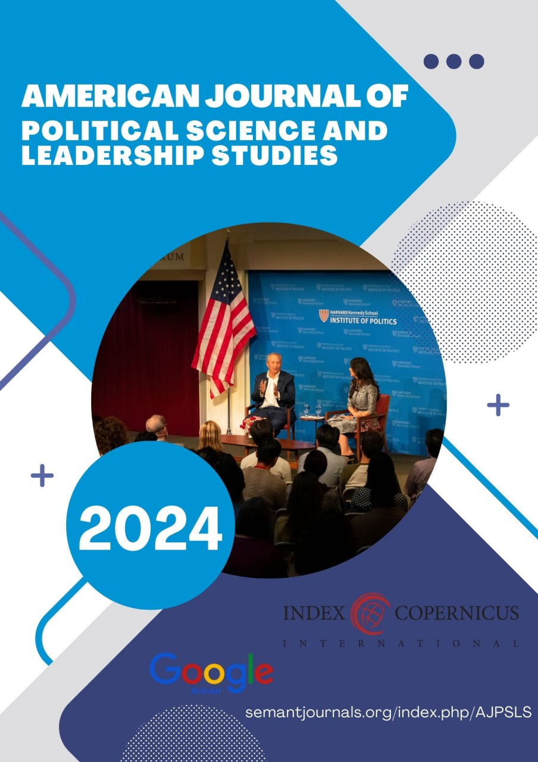
E-ISSN: xxxx - xxxx

American Journal of Religious, Culture, and Archaeological Studies
https://semantjournals.org/index.php/AJRCAS

| Research Article

Civilization of Central Asia

Khaitova Sevinch
Student of Asian Technology University

Abstract: By now, culture has reached its peak. But culture also developed in ancient times. In particular, culture began to develop from the process of human civilization. At the same time, in a time when attention to the history of the Motherland has increased, there is no doubt that the territories of Uzbekistan are one of the centers of world civilization from the earliest times. Not only that



This is an open-access article under the CC-BY 4.0 license

INTRODUCTION

There was no doubt about it after seeing the research work being carried out in Uzbekistan, which is our homeland, but also in the entire region of Central Asia. From this we can see that there is no doubt that our country is one of the hotbeds of world civilization.
The word "civilization" is associated with the definition of a qualitative boundary in the history of mankind. The emergence of this concept is the achievement of European science and literature during the Enlightenment. But the first concepts of civilization arose much earlier. In ancient times, people began to compare their world with the world of others. Although not defined by the word civilization in antiquity, they contrasted barbarism with their level of development. The word "civilization" comes from the Latin "civilis" meaning "citizenship", "state", "pertaining to the city". It is used in the opposite sense of the word "silvaticus", which means rough, wild when translated from Latin. The concept of civilization appeared inextricably linked with the concept of "culture". Initially, the concepts of culture and civilization were used as synonyms, but gradually a difference between these two terms appeared.
The concept of civilization reflects the achievements of the peoples living in different parts of the world in different periods of history, in socio-economic and cultural processes, and their rise to the stage of development. This stage of development is explained by the emergence and development of humanity, the level of development of society, the rise of material and spiritual culture, and mutual relations between tribes and peoples.
Central Asian civilization appeared and developed in different regions in different periods. For example, the ancient tribes living in the southern regions switched to farming and developed a productive economy as early as the 6th millennium BC, while the tribes in the northern regions were mainly engaged in the first forms of hunting, fishing and animal husbandry. This non-textual process can be explained by the natural-geographical conditions and mutual relations. In addition, it can be known from the products created by various tribes in Central Asia that the culture is the mutual relations of the ancient population since the Neolithic period, i.e., from the VI-IV millennium BC, and this The close contact of the population with other ancient centers of civilization in the East, first of all, in Old Asia, had a great impact on the development of the local civilization.
The primitive community system is the longest-lasting and oldest form of human society that we know of. The importance of archeology, ethnography, anthropology, and geology is incomparable in the in-depth study of this period. During their activities, ancient people influenced the environment, made tools for daily life, looked for places to live, looked for and certainly found them. Later, they built shelters. In turn, these processes had a great impact on human activity, that is, silivization.
The sister nations of Central Asia, that is, the Uzbek, Karakalpak, Tajik, Kazakh, Turkmen and Kyrgyz nations, are sister nations by origin.
The peoples of Central Asia made a great contribution to world civilization through their great thinkers, scholars, and leaders. In particular, before the invasion of the Arab peoples, Zoroastrian religion existed in this area, and the representatives of this religion worshiped fire, water, air, and the sun. After the Arab invasion, we would not be mistaken if we say that the peoples of Central Asia explained what Islam is to the Arabs. For example, the fact that great thinkers such as At-Tirmidhi, Al-Farabi, and Al-Bukhari lived is a clear proof of this. In addition, thinkers Alisher Navoi,
We can give an example of Babur, Ibn Sina, Al-Farghani, and several other scholars, such as the great general Amir Temur, Jalaluddin Manguberdi, Najmuddin Kubro.
Currently, the development of primitive society in Central Asia is divided into the following periods:
The Paleolithic period: began about 800 thousand years ago and ended 15-12 thousand years ago:
- Mesolithic (mesos-middle, lithos-stone) BC. 12-7 millennia
-Neolithic (neos-new, lithos-stone) - BC. 6-4 millennia.
- Eneolithic (copper-stone age) - BC. The end of the 4th millennium - the beginning of the 3rd millennium.
-Bronze age-millennium BC. 3-2 millennia
-Iron Age - BC From the beginning of the 1st millennium
The settlements of the oldest people in the territories of Uzbekistan were found in Selungur in the Fergana valley, Kolbuloq in the Tashkent region, and Uchtut in Bukhara. The people of this period made rough weapons (choppers) from stones, were engaged in team building and collective hunting. Early Paleolithic people were physically and mentally different from modern people. They are powerless in front of the nature and have mastered the products prepared in it.
Settlements of people who lived at the end of the First Paleolithic, that is, the Ashelian period, were also found and studied in Borsakelmas, on the Ustyurt plain of Karakalpakstan.
The sites of the Middle Paleolithic period were found in the Obirahmat, Khojakent, Samarkand, Teshiktash sites in the Boysun mountains. One of the famous monuments is the Teshiktash cave, where besides various weapons and animal bones, the grave of a 9-10-year-old boy was excavated.
By the Middle Paleolithic period, the working tools of the people of the primitive society were improved. The most important thing is that the transition from the primitive group to the seed-producing community begins.
Fire is discovered as a result of the movement of a huge glacier from the north. Group hunting appeared. Settlements of people who lived at the end of the Early Paeolithic, that is, the Ashelian period, were also found and studied in the Borsakelmas region of the Ustyurt Plain of Karakalpakstan.
The sites of the Middle Paleolithic period were found in the Teshiktash cave in the mountains of Obirahmat, Khojakent, Samarkand, Boysun mountains in the Tashkent oasis. One of the famous monuments is the Teshiktash cave, where, in addition to various weapons and animal bones, the grave of a 9-10-year-old boy was excavated.
By the Middle Paleolithic period, the working tools of the people of the primitive society were improved. The most important thing is that the transition from the primitive group to the seed-producing community begins.
Fire is discovered as a result of the movement of a huge glacier from the north. Group hunting appeared.
Findings from the Late Paleolithic period were found in Kolbuloq in Ohangaron, Buzsuv (Bozsuv) 1 located in the west of Tashkent, and Samarkand. By this time, people began to spread not only to the mountainous regions, but also to the plains. The biggest achievement in this period is the transition to the seed system (matriarchy).
The monuments of the Mesolithic period were found and studied in the Machoi cave-place in Surkhandarya, and in many monuments of Central Fergana. By this time, the glacier will return to the north. Big changes are taking place in the world of animals and plants. Mankind discovers the bow and arrow, which is the first complex device in its history.
The tribes of the Mesolithic period were mainly engaged in hunting and livestock farming. Towards the end of this period, the first domestication or domestication of animals begins. And this is now being improved in training animals and hunting (dogs). In Karakalpakstan there are Mesolithic sites in the Ustyurt Heights around the Aral Sea and in the Kyzylkum Desert. Mesolithic sites in Ustyurt BC. 8-6 thousand years old. The monuments of the Mesolithic period found in the Kyzylkum desert belong to the last stages of the Mesolithic and the period of transition from the Middle Stone Age to the New Stone Age (Neolithic).
By the Neolithic period, great changes took place in the life of ancient tribes. The people of this period were engaged in fishing and hunting or agriculture and animal husbandry and partly handicrafts. One of the greatest achievements is the emergence of pottery. Also, by this period, textile and boat building also appeared. The tribes of the Neolithic period are divided into the following cultures depending on the forms of economy: Jaytun culture, Kaltaminor culture, Hisar culture
Joytun culture. BC in Southern Turmanistan. VI-V millennium culture. The remains of the first thatched houses in Central Asia, samples of pottery were found here. The inhabitants were mainly engaged in agriculture, cattle breeding and partly hunting.
The oldest period - for Central Asia, includes the period from the beginning of mankind to the Arab conquest. By this time, the tribes living on the shores of the present Aral Sea and whose way of life was not similar to that of other tribes lived. They were engaged in hunting and fishing because of their proximity to water. Later, they engaged in animal husbandry and agriculture. The unique culture created by these tribes is called "Kaltaminor" culture. It was found in the south of Karakalpakstan and belongs to the VI millennium BC. In general, by this time, the technique of making weapons was much improved. We can see this from the weapons found at Caltaminor. They were more comfortable, sharper and lighter. Such weapons are mainly made of limestone. Limestone in its pure state is slightly more brittle, so it can be shaped into any shape. As a result of scientists' research, they have come to the conclusion that the limestone may have been taken from Sultonuwais mountain. As a result of the research, it was found that the people of that time knew enough about this mountain . Because a Neolithic workshop and stone-cutting rooms were found on this mountain. The most rare and important monument of Kaltaminor culture is Jonbos-4 settlement, the area of which is 300 m. sq. the remains of a teapot were found. It turned out that a large clan community lived in Chaila, 100-120 people lived there. Based on the study of burnt reeds and sticks, scientists came to the conclusion that the chayla was columnar, oval in shape and covered with reeds. One large and more than 20 small hearths were recorded in Chaila. Around the hearths were found fish (piper, drum), animal (bog, gazelle, Bukhara deer, etc.), bird bones and eggshells, as well as a number of small stones. Also, round pottery vessels were found, on the surface of which drawings were drawn. It is interesting to note that similar objects were also found in the Kaltaminor settlement. This situation indicates that there were mutual relations between the settlements. The analysis of the found objects showed that these settlements correspond to 7-3 thousand years BC. This location is the present Republic of Karakalpakstan
18 km from Tortkol city. called the Caltaminor culture after the Caltaminor lake in the northeast. Archaeologists divide Kaltaminor culture into 3 periods depending on the dynamics of development: 1. The first period of Kaltaminor corresponds to 7-5 thousand years BC. 2. The middle period of the Kaltaminor culture is 5-4 BC 3. The last stage of the Kaltaminor culture belongs to the 4-3 millennia BC We can know from the fact that the monuments of this period were found in the lower reaches of Zarafshan, the Kyzylkum desert and the southeastern Ustyurt region. , our people had a great impact on world civilization.
Hisar culture. It is mainly found in the Khisar-Pamir mountains. It belongs to the V-IV millennia BC.
In Karakalpakstan, people of the new stone (neolithic) age began to master not only the shores of the Dare, but also the inner regions of Kizilkum and Ustyurt. The monuments of the New Stone (Neolithic) period in Karakalpakstan were preserved in the ancient Okchadarem delta of the Amudarya River (from the present day Tortkul district to the territory of Takhtakupir district) and Ustyurt height. In the Eneolithic-copper-stone period, people got acquainted with the first metal. By this time, agriculture spread to the northeastern regions of Central Asia. One of the problems of the primitive community system, which causes various debates, is the emergence and development of man - anthropogenesis. Science suggests that humanity is separated from animal breeding. The emergence of man is the result of the development process that lasted for millions of years.
During the Middle Stone Age, primarily as a result of the development of human thinking in the process of labor, Neanderthal-like people began to turn into the people of their current form. They matured from a physical point of view, people in their current form were born, and thus the process of anthropogenesis ended (people in the form of Cromans). The appearance of man is one of the greatest phenomena on earth, and he made a simple hammer out of stone, but as a result of continuous work and striving, he reached the level of creating a high culture.
In the history of the world, primitive visual art, in particular, drawing various images on the walls of caves, belongs to the last Paleolithic period. In Central Asia, paintings made on caves, ungurs and rocks appeared in the Mesolithic period.
The rarest examples of rock paintings in Uzbekistan are Zarautsoy, Sarmishsoy, Birinsoy, Koksaroy, Takatosh, Teraklisoy, and there are more than a hundred of them. On the rocks here, you can observe pictures of representatives of the ancient and modern animal world of Uzbekistan. Among them are primitive bulls, lions and tigers, leopards, foxes and wolves, deer and gazelles.
The oldest paintings are from Zarautsoy (Surkhondarya), these paintings are Mesolithic-Neolithic, that is, BC. It belongs to the VIII-IV millennia. Through the rock paintings, we can learn the hunting, working and fighting weapons of the people of that time. Rock paintings are also important in studying the ideological views and religious beliefs of our ancient generations.
According to many researchers, the homeland of bronze was Asia Minor and Mesopotamia. Mil. avv. By the 3rd millennium, bronze weapons were widespread in Central Asia. There are many bronze age monuments in the territory of Uzbekistan.
The largest of them is Tazabog`eb. Monuments of Zamonbobo, Sopollitepa, Jarqutan, Churs, Amirabad. During the Bronze Age, great changes took place in the cultural development of the human society. The population switched to certain forms of farming, i.e. to farming in oases, along lakes, rivers and streams, to animal husbandry (the first major division of labor) in the steppes and highlands. By this time, O' the processes of change also took place in the social system of Central Asia. Although the system of breeding continued in the Bronze Age, the status of the mother clan was disappearing. Due to the development of metal smelting and economy, the work and status of men in the society became of the first importance. Dominance in production will pass to men and the system of the mother's clan will be replaced by the system of the father's clan (patriarchy).
The largest monument of the Bronze Age in the territory of Karakalpakstan is the monument called Tazabog`eb culture. Tazabog`eb culture. avv. The irrigated agriculture of Karakalpakstan developed in the middle of the 2nd millennium.
At the end of the Bronze Age, irrigation of the land was further developed. Remains of a monument called Amirabad were found in the south of Karakalpakstan in the territory of the current Turtkul district. Historians-archaeologists found traces of irrigation canals with a length of one kilometer from here.
It can be seen that the peoples of Central Asia had a great influence on world culture. We can know that the above-mentioned period is the oldest period, and during this period the peoples of Central Asia were quite civilized.

REFERENCE:
Isanova, F. (2023). STRUCTURAL AND SEMANTIC ANALYSIS OF THE TERMS OF INTERNATIONAL LAW IN ENGLISH AND UZBEK LANGUAGES. Евразийский журнал социальных наук, философии и культуры, 3(1 Part 1), 76-80.
Isanova, F. (2022). STRUCTURAL-SEMANTIC CHARACTERISTICS OF LEXICAL UNITS IN THE FIELD OF INTERNATIONAL LAW IN ENGLISH AND UZBEK. Science and Innovation, 1(7), 943-946.
qizi AMINOVA, D. K. INTERNET JOURNALISM OF CHINA AND PROBLEMS OF NATIONAL SELF-CONSCIOUSNESS.
Qizi, A. D. K., & Muxammedjanovna, Y. M. (2020). Increasing the role and position of internet media in activation of intercultural communication. International Journal of Scientific and Technology Research, 9(1), 1749-1757.
Kholboboeva PhD Student, A. (2020). The notion of advertising discourse in modern uzbek linguistics. Philology Matters, 2020(2), 102-113.
Xabibiloyevna, M. D., & Sirojiddin o’gli, A. M. R. (2023). CLASSIFICATION OF DISCOURSE ACCORDING TO DISCIPLINE. " XXI ASRDA INNOVATSION TEXNOLOGIYALAR, FAN VA TAʼLIM TARAQQIYOTIDAGI DOLZARB MUAMMOLAR" nomli respublika ilmiy-amaliy konferensiyasi, 1(5), 156-161.
Meylibaevna, K. M. (2023, May). ADVERTISING TEXT LINGUISTIC CHARACTERISTICS. In INTERNATIONAL SCIENTIFIC CONFERENCES WITH HIGHER EDUCATIONAL INSTITUTIONS (Vol. 3, No. 08.05, pp. 125-128).
ALIMOVA, K. T. (2019). Idioms With A Floral Component And Difficulties Of Their Translation. Иностранные языки в Узбекистане, (2), 128-137.
Toshtemirovna, P. Z. (2017). English proverbs with numeral component and their Uzbek equivalents. Евразийский научный журнал, (1), 219-221.
Алимова, К. (2021). Гид-таржимон нутқида риториканинг ахамияти. in Library, 21(4), 39-42.
Алимова, К. (2021). Гид-таржимон нутқида риториканинг ахамияти. in Library, 21(4), 39-42.
Alimova, K. T. The Role of Guide-Translator in the development of tourism Industry. Электрон//International Journal of Research e-ISSN, 2348-6848.
Мусабекова, М. (2023). Проблемы и особенности перевода научного текста. Арабский язык в эпоху глобализации: инновационные подходы и методы обучения, (1), 445-450.
Narimanbekovna, M. M. (2024). Stylistic features of discourse and features of their translation. Texas Journal of Multidisciplinary Studies, 29, 13-15.
Musabekova, M. (2024). SCIENTIFIC AND TECHNICAL TRANSLATION AND ITS TYPES. Science and innovation in the education system, 3(3), 25-29.
Алиева, З. Р. (2024). ТЕОРИЯ РЕЧЕВОЙ ДЕЯТЕЛЬНОСТИ В КОНТЕКСТЕ ПСИХОЛИНГВИСТИКИ. SCHOLAR, 2(5), 121-126.
Алибаева, Л. Н. (2017). Метод проектов на уроках английского языка как условие развития личности ученика. Вестник современной науки, (2-2), 17-19.
Alibaeva, L. (2022). Роль и место дистанционного обучения в образовании. Science and innovation, 1(B6), 79-81.
Namazovna, A. L. (2018). The importance of using authentic materials in ESP classes. Евразийский научный журнал, (6), 255-256.
Алибаева, Л. (2022). Понятие принципа интеграции в построении образовательного процесса. Общество и инновации, 3(2/S), 159-163.
Алибаева, Л. Н. (2021). ДРЕВНЕРУССКАЯ ЛИТЕРАТУРА. Academic research in educational sciences, 2(4), 1112-1116.
Алибаева, Л. Н., & Шадыева, Ш. Ш. (2021). ОБЩЕНИЕ ЗРЕНИЯ ПОЛЕЙ В РУССКОМ ЯЗЫКЕ. Энигма, (30), 89-92.
kizi Abdurakhimova, T. A. (2024). Objective Factors Affecting Uzbekistan's Access To The Bologna Agreement. Texas Journal of Multidisciplinary Studies, 29, 16-19.
kizi Abdurakhimova, T. A. (2024). THE INFLUENCE OF THE BOLOGNA PROCESS ON YOUTH’S WORLDVIEW. Confrencea, 1(1), 270-274.
Mukhidinovich, J. O. (2024). UNDERSTANDING EMOTIONAL INTELLIGENCE. Universal Science Perspectives International Scientific Practical Journal, 1(1).

Ganieva, U. A. (2021). The digital economy and its benefits. TRANS Asian Journal of Marketing & Management Research, 10(4), 29-34.
Ganieva, U. A., & Mirzaeva, M. G. K. (2022). Types of Digital Banking Services and Increasing Their Popularity. International Journal of Multicultural and Multireligious Understanding, 9(6), 1-5.
Ganiyeva, U. A. (2019). Problems and prospects of development of investment activity of banks. Экономика и бизнес: теория и практика, (1), 48-50.
Abdugaffarovna, G. U. (2023). Priority Directions for Reforming the Banking System in the Republic of Uzbekistan. Journal of Innovation in Education and Social Research, 1(2), 4-6.
Abdugaffarovna, G. U. (2023). THE DIGITAL ECONOMY AND ITS BENEFITS. Academia Science Repository, 4(04), 51-58.
Abdugaffarovna, G. U. (2023). BANK RESURSLARINI SHAKLLANTIRISH VA FOYDALANISH. Journal of new century innovations, 26(4), 55-57.
Kh, Ikromova P. "Sexual Dysfunction in Women Suffering From Gynecological Diseases." Central Asian Journal of Medical and Natural Science 4.1 (2023): 313-317.
Ikramova, P. X., and M. Mansurova. "VULVOVAGINITIS WITH HELMINTHOSIS: EPIDEMIOLOGY, PATHOGENESIS AND TREATMENT." JOURNAL OF HEALTHCARE AND LIFE-SCIENCE RESEARCH 2.4 (2023): 67-73.
Parvina, Ikromova. "The Role of Infections in Obstetrics and Perinatal Pathologies." EUROPEAN JOURNAL OF MODERN MEDICINE AND PRACTICE 4.3 (2024): 99-103.
Khamidovna, Ikromova Parvina. "Modern Approaches in the Diagnosis of Premature Rupture of Membranes in Pregnant Women." Research Journal of Trauma and Disability Studies 3.3 (2024): 215-218.
Yasakov, Z. X., & Sh, K. M. (2022). ISHLAB CHIQARISHDA FAOLIYAT XAVFSIZLIGI VA MEHNAT MUHOFAZASINI TASHKIL ETISH. BOSHQARUV VA ETIKA QOIDALARI ONLAYN ILMIY JURNALI, 2(6), 19-21.

